 |  | 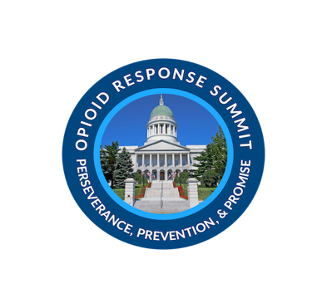
Governor Mills 3rd Annual Opioid Response Summit
Perseverance, Prevention and Promise
Thursday, July 15, 2021
8:00 AM - 3:30 PM EST
8:00 |  | Welcoming Remarks
 |  | Gordon Smith, Director of Opioid Response
 |  | Dr. Nirav Shah, Maine CDC Director
8:30 |  | A Conversation with Erin French
 |  | Moderated by Governor Janet T. Mills
9:00 |  | Xavier Becerra, United States Secretary of Health and Human Services
9:10 |  | Remarks by Attorney General Aaron Frey
9:25 |  | Breakout Session I- Select 1. Includes Voice of Recovery (5 Mins)
 |  | Recovery Friendly Workplaces and Stigma Reduction - STREAM 1
 |  | An Evaluation of the Maine Treatment Courts and their Impact on Reducing Recidivism and Lowering Costs - STREAM 2
 |  | Advancing Medication Assisted Treatment in Corrections - STREAM 3
10:15 |  | Break- Poster Session Cont.
10:30 |  | Breakout Session II- Select 1. Includes Voice of Recovery (5 Mins)
 |  | Maine MOM Initiative: Integrated Care for Pregnant and Postpartum Women with Opioid Use Disorder - STREAM 1
 |  | Compassionate Opioid Tapering at a Rural FQHC; Lessons, Methods, and Resources for Deprescribing in the Face of the Opioid Epidemic - STREAM 2
 |  | Examining the Link Between Suicide and Opioid Misuse - STREAM 3
11:20 |  | Remarks by Governor Janet T. Mills and Presentation of Distinguished Service Award
12:00 |  | Lunch- Poster Session Cont.
12:30 |  | Recovery in Maine: Androscoggin County
 |  | A film about relentless hope, resilience, and recovery
12:45 |  | Regina LaBelle, J.D., Acting Director of the White House Office of National Drug Control Policy
1:35 |  | Breakout Session III- Select 1. Includes Voice of Recovery (5 Mins)
 |  | Understanding Multiple Pathways and the Role of Medication in Recovery - STREAM 1
 |  | Preventing Substance Use Disorders by Mitigating Adverse Childhood Events - STREAM 2
 |  | Supporting Families and Protecting Children: A Systems Approach to Strengthening Families Impacted by Substance Use Before, During & After the Pandemic - STREAM 3
2:25 |  | Break- Poster Sessions Cont.
2:40 |  | Breakout Session IV- Select 1. Includes Voice of Recovery (5 Mins)
 |  | A Wabanaki Vision of Recovery: The Journey to Building Culturally Supportive SUD Continuum of Care - STREAM 1

Promoting Health Equity and Prevention through Youth Engagement Best Practices -

STREAM 2
 |  | The Impact of the COVID-19 Pandemic on People Who Inject Drugs Accessing Harm Reduction and Substance Use Disorder Treatment in Maine - STREAM 3
3:30 |  | Remarks Dr. Jessica Pollard, Director, Office of Behavioral Health Maine
3:45 |  | End of Day

